|  |  |
| --- | --- |
| Acero website -cms  Content Management Structure and Workflow Guide | Abstract  The ACERO Website – CMS document outlines the structure, approval workflows, and notification settings used within the content management system. It defines access levels for admins and editors/reviewers/approvers across various modules, including webpages.  Website URL: https://acero.ae/ |

# Acero Website Contents

**ACERO CMS – Documentation Index**

**1. Dashboard - Overview of CMS statistics and activity summary.**

**2. Projects**

**Add New Project**

**All Projects (with approval workflow)**

**3. Brochure**

**Add New Brochure (multi-language support)**

**All Brochures (Title, File, Status, Options)**

**4. Branch**

**Add New Branch**

**All Branches**

**5. Company Updates**

**All Posts**

**Add New Post**

**6. Marketing**

**Email Templates Module**

**Admin Email Templates**

**Customer Email Templates**

**Common Templates**

**7. Enquiry & Application**

**Enquiries**

**Applications**

**Vacancies**

**8. Website Pages Setup**

**All Website Pages**

**9. Setup & Configurations**

**Authentication Layout and Settings**

**SMTP Settings**

**Header & Footer**

**10. Activity Logs**

**11. Staffs**

**Staff Mapping**

**All Staffs**

**Staff Permissions**

**Versions Specification**

|  |  |  |
| --- | --- | --- |
| Item | Details Known | To be Confirmed / Provided |
| Admin login URL | *https://acero.ae/admin* | backup admin URL if any |
| Hosting provider | Hostinger | Control panel access details (cPanel or Hostinger dashboard), FTP / SFTP / SSH credentials |
| Server environment | PHP + MySQL | PHP version(s) – 8.2.29 MySQL version – 8.0.43 other needed software - |
| Version control / code repository | *GIT* | git repo(s) store the pages/branches-gitlab, tester/main/Shadab/ |
| User roles & permissions | *Can be modified in Super Admin* | Yes |

**CMS**

CMS access control and enforces the **three-tier content approval workflow** — **Editor → Reviewer → Approver**.

It ensures only approved and verified content is published live on the ACERO website.

|  |  |  |  |
| --- | --- | --- | --- |
| Stage | Role | Description | Notifications |
| Editor | Creates or edits content. | Can edit any assigned modules and submit for review. | Send mail to Reviewer and Approver. |
| Reviewer | Reviews Editor’s submission. | Can approve or reject with comments. | Approval → Approver notified. Rejection → Editor notified with comments. |
| Approver | Final publishing authority. | Can approve (makes content live) or reject (sends back to Editor). | Sends notification to Editor and Reviewer after action. |

Overall summary of Workflow across different modules in CMS

|  |  |  |
| --- | --- | --- |
| Approval Workflow | Only Notified in mail | Not Notified |
| Project | **Project Module Sub fields**   * Building Types * Industries | **Project Module Sub fields**   * **Country** * **Region** * **Area** |
| Webpage setup – All Pages   * Homepage * About Us * Pre-Engineered Steel building * Conventional Steel * Warehouse Racking System * Portacabin * Accessories * Peb Comparison * Product * Manufacturing * Contact Us * Career * Videos * Literature * Thank You | Brochure | Mail Templates |
| Homepage settings | Branch | **Set up & Configuration** |
| Company Updates | - | **Company Updates Sub Fields**   * Categories |
| - | Vacancies | **Staff Mapping & Permissions** |
| - | - | * **Enquires(Download and View)** * **Applications(Download and View** |
|  |  |  |
|  |  |  |

Note terminologies used across in all modules:

* **Thumbnail Image:** Small preview image used to represent a page, post on website.
* **Featured Image/Post:** Highlighted image/Post displayed on the homepage slider or featured section
* **Banner:** Large image displayed at the top of a website for visual emphasis or branding.
* **Company Gallery:** Collection of company-related images showcasing projects, events inside the page or projects on website.

Dashboard

Displays an overview of the entire site’s activity, including total projects, regions, areas, countries, Industries, building types, Inquires, Application, Brochures, Company A screenshot of a computer

Projects Module **- https://acero.ae/projects/category**

Main section for managing all projects listed on the website.

**Menu Items**

* **All Projects** → View, filter, or edit existing projects depending on logged in user permissions also make the selected project featured.
* **Add New Project** → Create a new project entry.
* **Building Types** → Manage Building Types (e.g., Agri-products Warehouse, Airport Terminal) which will be available in drop down while adding new projects.
* **Industries** → Manage Industries (e.g., Retail and commercial, Warehousing) which will be available in dropdown while adding new projects.
* **Countries / Region / Area** → Define classification data for filtering projects on the site. This can be accessed by super admin only and these fields do not follow any workflow or notified.

**Add New Project – Field Descriptions**

|  |  |
| --- | --- |
| Field | Description |
| Building Type | Select the project’s building category. Used for filtering and grouping on the website. |
| Job Number | Internal project identifier or contract reference. |
| Slug | Unique project URL slug (auto-generated if blank). Example: project-name. |
| Order | Display order for sorting projects on the site. Lower numbers appear first. |
| Thumbnail Image | Upload the image used in listings and previews. Recommended: 500×500px.(Displayed in below screenshot) |
| Project Images | Upload main gallery images. Multiple uploads allowed.(Once particular project is clicked one can see all uploaded img) |
| Project Name | Display name of the project. |
| Area | Geographic area (e.g.,). |
| Country | Select the project’s country. |
| Industry | Define the project’s business/sector type. |
| Special Features | Describe key highlights (custom rich text editor). |
| Total Area | Specify the total area covered (sq. ft / m²). |
| Meta Title | SEO page title shown in browser tab and search results. |
| Meta Image | Upload preview image for SEO or social sharing. |
| Meta Description | Short description for search engines. |
| Meta Keywords | Comma-separated keywords for SEO optimization. |
| Approval Comments | Internal comments section for reviewers/approvers. Appears during workflow. |
| Save Button | Saves current form data. Behavior depends on user role (Editor: saves draft / Reviewer: updates status / Approver: publishes). |

**Screenshot of fields in website**

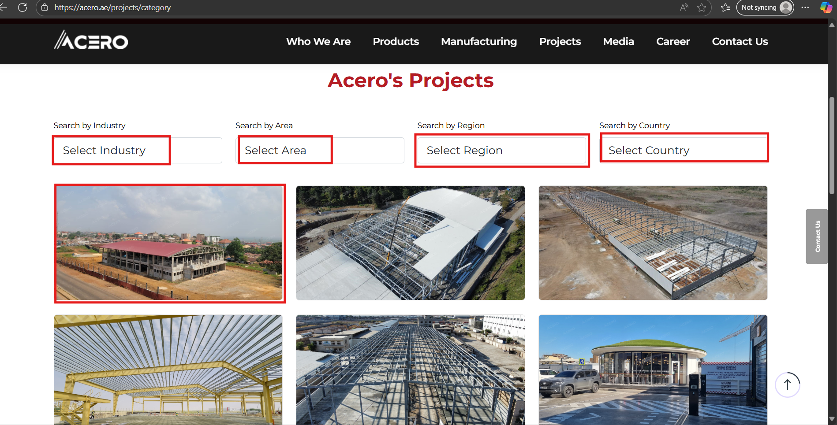

**Approval Workflow for Projects Module**

|  |  |  |  |
| --- | --- | --- | --- |
| Stage | Performed By | Action | Outcome |
| Submit for Review | Editor | Fills project form and clicks **Save**. This marks project as ready for review | Project is just saved, not visible on live site. Reviewer notified via dashboard notification/email. |
| Review | Reviewer | Can be viewed under options (Changes). Checks project data, media, and metadata | Can Approve → send to Approver, or Reject → return to Editor with comments. |
| Approval | Approver | Verifies and approves content | If approved → Published on site. If rejected → Sent back with rejection reason to editor. |

**Rejection Flow**

1. Reviewer/Approver enters comments in the Approval Comments field.
2. Clicks Reject / Request Changes.
3. Editor receives notification and reopens the project for modification.
4. After correction, Editor resubmits for review.

# Brochure - https://acero.ae/literature

Used to create and manage brochures displayed on the **Acero website**.  
Each brochure entry contains a title and an image (usually a brochure cover or downloadable visual).

|  |  |
| --- | --- |
| Menu | Description |
| Add New Brochure | Create a new brochure entry (language-wise). |
| All Brochures | View, filter, or edit existing brochures. Also used to toggle visibility status and manage uploaded files. |

All Brochure

|  |  |
| --- | --- |
| Column | Description |
| Title | Brochure name |
| File | Displays uploaded file or thumbnail preview. |
| Status | Toggle switch to mark brochure **Active/Inactive**. Active = visible on live site; Inactive = hidden. |
| Options | Action buttons such as *Edit*, *Delete*, *Preview as per staff permission* |

**Add New Brochure**

|  |  |
| --- | --- |
| Column | Description |
| Title | Brochure name (Highlighted in below screenshot) |
| Brochure Image | Displays uploaded file like thumbnail preview. |
| Brochure | Can upload actual brochure file (Any Language) |
| Language | The language in which brochure is uploaded we can specify it here.(Refer below screenshot) |

Mapping in Website

# Branch - https://acero.ae/contact-us

The **Branch** module is used to add, edit, and maintain details of all company branches, including the head office.  
Each branch record contains essential contact, location, and operational information for display or internal use.

There is **no approval workflow**, but **Reviewer and Approver** receive **email notifications** whenever a branch is created or updated by Editor  
A **toggle option** is available to mark one branch as the **Head Office**.

|  |  |
| --- | --- |
| Menu Option | Description |
| Add new Branch | Add new branch details, including location, manager, and logo. |
| All Branches | View, edit, or delete branch entries. Toggle head office status or manage branch activation. |

**Add new Branch**

|  |  |
| --- | --- |
| Column | Description |
| Name | Branch name as entered by the editor. |
| Google Link | To display maps view in website as highlighted in screenshot |
| Select Manager | Assigned manager name. |
| Logo | Logo image displayed near address in the website. |
| Email / Phone /Alternate Phone | Contact email address, Primary and secondary contact number. |
| City / State / Country | Branch location hierarchy. |
| Head Office | To mark this branch as the head office (only one can be active at a time). |
| Address | Full branch address. |
| Working Hours | Specify the working hours according to the locations time zone. |

**Add new branch in CMS**

**Mapping in Website**

# Company Updates Module - https://acero.ae/company-update

The **Company Updates** module is designed to manage posts, announcements, and event updates published on the website.  
It includes two sub-sections — **All Posts** and **Categories** — for organizing and displaying content efficiently.

This section includes a **full approval workflow**, with notification emails to the **Reviewer** and **Approver** after submission or modification by editor.

|  |  |  |
| --- | --- | --- |
| Role | Permissions | Description |
| Editor | Create, edit, and resubmit posts. | Cannot publish directly. |
| Reviewer | Validate content, images, and SEO tags. Add approval comment. | Can approve for next stage or reject. |
| Approver | Final approval authority. Publishes post to live site. | Can revert post back to Editor if corrections needed or can approve so changes will be live |

**Fields**

|  |  |
| --- | --- |
| Column | Description |
| Title | Post title as entered by the editor. |
| Category | Displays the selected post category. |
| Event Date | The scheduled or occurred event date. |
| Featured | Toggle switch to mark post as “Featured.” Featured posts appear on the **Homepage slider or highlights section**. |
| Status | Indicates whether post is Active/Inactive. |
| Options | Includes edit, delete, and preview actions. |
| Banner Image | A Button to upload banner image for the category of post added. |

**Mapping in Company Website(If featured appears in homepage)**

**Company Update(If not featured)**

## Marketing

**Marketing** section manages all automated email notifications sent from the ACERO website.  
This module allows authorized users to:

* View, edit, and manage predefined email templates.
* Configure default recipient email addresses for incoming forms (via **Set Received Emails**).
* Enable or disable email templates as needed.

Email Templates commonly have below fields

|  |  |
| --- | --- |
| Column | Description |
| Email Type | Defines the function or purpose of the email (e.g., Password Reset, Contact Form). |
| Subject | Subject line of the email. Can include placeholders like [[store_name]] or [[visitor_purpose]]. |
| Status | Indicates if the email template is active/inactive. |
| Actions | Edit or delete options for each template. |

The **Email Templates** in the Marketing section contains

* Admin Email Templates
* Customer Email Templates
* Common Email Templates
* Set Received Emails

**Admin Email Templates**

|  |  |  |  |
| --- | --- | --- | --- |
| # | Email Type | Subject | Description |
| 1 | **Vacancy Application** | ***Job Application for [[visitor_vacancy]]*** | **Triggered when a job application is submitted. Sent to admin.** |
| 2 | **Contact Form** | ***Online Enquiry – [[visitor_purpose]]*** | **Triggered when a user submits a contact/enquiry form. Sent to admin.** |
| 3 | **Password Reset** | ***Password Reset – [[store_name]]*** | **Sent to admin users when a password reset request is initiated.** |

**Customer Templates**

**Default Customer Templates**

|  |  |  |  |
| --- | --- | --- | --- |
| # | Email Type | Subject | Description |
| 1 | **Vacancy Application** | *Your application has been submitted successfully at [[store_name]]* | Auto-sent to candidates after applying for a job. |
| 2 | **Contact Form** | *Your enquiry has been submitted at [[store_name]]* | Auto-sent to users when submitting a contact/enquiry form. |

**Common Templates**

|  |  |  |  |
| --- | --- | --- | --- |
| # | Email Type | Subject | Description |
| 1 | **Password Reset** | *Password Reset – [[store_name]]* | Sent to admin users when a password reset request is initiated. |

**Set Received Emails**

* This section defines **recipient addresses** for form submissions and automated messages received from the website. Located at **top-right corner** of all three Email Template pages.
  + **CAREER RECEIVED EMAIL** — defines the mailbox where job applications are sent.
  + Default configured address: info@acero.ae.

|  |  |  |
| --- | --- | --- |
| Field | Description | Notes |
| CAREER RECEIVED EMAIL CONTACT RECEIVED EMAIL | Email address that receives job applications. | Default: info@acero.ae |

**Save Configuration**

* Located at **top-right corner** of all three Email Template pages.
* Applies changes made to templates and received email settings.
* A confirmation message appears after saving successfully.

**Template Editing**

Each email template can include **placeholders** that the system automatically replaces at send time:

|  |  |
| --- | --- |
| Placeholder | Description |
| [[visitor_name]] | Name of the form submitter. |
| [[visitor_email]] | Email ID of the visitor. |
| [[apply_for]]  [[department]] | Position title for job applications. |

# Enquiry & Application - <https://acero.ae/contact-us> and https://acero.ae/career

The Enquiry & Application module manages three key operational areas of the ACERO website:

1. Vacancies — for listing and managing job openings.
2. Enquiries — for capturing and responding to contact form submissions.
3. Applications — for storing and managing job applications submitted online.

These modules help streamline recruitment and communication, with built-in notification and export features.

1. **Vacancies**

Manages all open job positions available on the website. New vacancies created here are displayed publicly for applicants to apply through the Career section.

|  |  |
| --- | --- |
| Column | Description |
| Name | Vacancy name (e.g., Design Manager). |
| Parent Vacancy | Defines hierarchical grouping (e.g., “Engineering” parent for related sub-vacancies). - Now by default its No parent |
| Order | Controls listing priority — higher number = higher display order. |
| Status | Active or Inactive (visibility on site). |
| Action | Edit, delete, or view details. |

**Add New Vacancy**

|  |  |  |  |
| --- | --- | --- | --- |
| Field | Description | Input Type | Validation / Notes |
| Vacancy Name | Name of the open position. | Text box | Required. |
| Select Parent Menu | Optional parent category (for grouping related roles). | Dropdown | Optional. |
| Ordering Number | Determines display priority — higher number = higher priority on site. | Numeric | Required. |

**Mapping in Website**

# Workflow and Notification:

* There is **no formal approval flow**, but **Reviewer** and **Approver** receive email alerts upon vacancy creation or update.
* Changes become effective immediately after save (status toggle determines visibility).

1. **Enquiries**

Capture all contact form submissions from the website’s “Contact Us”. This section enables admins to review, download, and respond to user queries efficiently.

|  |  |
| --- | --- |
| Column | Description |
| Name | Name of the person submitting the enquiry. |
| Email | Sender’s email address. |
| Phone | Sender’s contact number. |
| Query | The message or enquiry content. |
| Reply | Optional admin response (if applicable). |
| Status | Indicates whether the enquiry is *Replied* or *Not Replied*. |
| Options | Edit, view, delete, or reply. |

**Screenshot of Enquires**

**Mapping in Website**

**Download Buttons:**

* Located at the **top-right corner**, allowing export of all enquiry data as:
  + **PDF,** **Excel,** **CSV**
* **Received Mail:**  
  Uses the settings from **Set Received Emails**, where info@acero.ae (or updated address) receives all enquiries.
* **Search & Filter:**  
  Advanced filters allow search by **Country, Filter by Date, or Text**.

**Workflow**

|  |  |  |
| --- | --- | --- |
| Action | Role | Behavior |
| Enquiry submission in website | Visitor | Email notification sent to **Admin** |
| Review/Reply | Admin | Admin can enter response in “Reply” field; status changes to *Replied*. |
| Export | Admin | Data exported as selected file type. |

1. **Applications**

Stores all job applications submitted from the **Careers** page.  
Each record includes applicant details, uploaded CVs, and cover letters.

**Fields**

|  |  |
| --- | --- |
| Column | Description |
| Name | Applicant’s full name. |
| Email | Applicant’s email address. |
| Phone | Contact number. |
| Apply For | The position applied for. |
| Department | The department associated with the vacancy. |
| Cover Letter | Text entered by the applicant in the submission form. |
| CV | Upload file link with **View** button for direct preview/download. |

**Search and Export Options**

* **Search Filters:**
  + Search by *Name*, *Email*, *Department*, or *Vacancy*.
  + Filters can be combined for specific result sets.
* **Download Options (Top Right):** allowing export of all enquiry data as Excel, PDF and in ZIP format.

**Workflow and Notifications**

|  |  |
| --- | --- |
| Step | Notification |
| Applicant submits form | Email sent to **Admin (CAREER RECEIVED EMAIL)** as configured in *Marketing → Received Mail*. |
| Admin reviews | No automatic approval flow; manual follow-up as needed. |

**Screenshot of Applications**

* CVs are stored securely with controlled access through the CMS.
* Only authorized roles (Admin/Reviewer) can view or download CVs.
* Email notifications ensure no missed application submissions.

# Website Pages Setup

The Website Pages Setup module manages the website’s pages (e.g., Home, About Us, Product Pages, Contact Us, etc.).  
 This section enables editors to modify individual page content, meta information, banners, and layout blocks directly within the CMS.

Each page record corresponds to a live page URL on the ACERO website.  
This module follows the complete workflow (Editor → Reviewer → Approver) and automatically sends notifications when changes are made or comments are added.

**All Pages**

|  |  |
| --- | --- |
| Column | Description |
| Name | Page name displayed in the CMS (e.g., Home Page, About Us). |
| URL | Direct link to the page on the public website. |
| Actions | Includes options to **View/Edit**, **Preview**, and **Comment**. |

**Add a new page**

By filling Title, Link, Slug (letters, numbers, hyphens only), Content, SEO fields (Meta Title, Meta Description, Keywords, Meta Image 150x150), and Changes Comment

|  |  |
| --- | --- |
| Feature | Description |
| Workflow | Follows full 3-level process (Editor → Reviewer → Approver). |
| Notifications | Automatic email notifications on each action. |
| Comments | Feedback across all roles (Approve/Reject) |
| Preview | Live/draft page preview before publishing. |

**Home Page -** https://acero.ae

* **Home Slider:** Add slide image, title, and content.
* **Section Two:** Add “Learn More” about-us content here.
* **Section Three:** Add important metrics like Manufacturing Capacity, Number of Employees
* **Certificates Section:** Add Title ISO 9001:2015, Link https://www.iso.org/standard/62085.html, and Image.
* **Product Section:** Add Title PEB, Link https://acero.ae/product/pre-engineered-steel-buildings, and Image PEB-1.png.
* **Customer Section:** Add Heading Our Customers, Title, and Image.
* **SEO Section:** To Add Meta Title, Meta Description, Keywords and Meta Image (150x150).
* **Changes Comment:** Add common comment for approval.

[**About Us**](https://acero.ae/about-us) **-** https://acero.ae/about-us

* **Banner Image:** Add banner image content.
* **Title:** Add content for Who We Are.
* **Section 2:** Add content for Reliability, Excellence, Trust.
* **Section 3:** Add content for Engineering Excellence.
* **Section 4:** Add content for Elevating Customer Experience.
* **Section 5:** Add content for Transforming Industries Globally.
* **SEO Section:** Add content for Meta Title, Meta Description, and Meta Image (150x150) same as before in Home Page

**PEB Page** - <https://acero.ae/product/pre-engineered-steel-buildings>

* **Home Banner:** Add banner image, title PEB, content, and corresponding component images, names, and content.
* **Why PEB?:** Add image, title PEB, and content.
* **PEB Model:** Add title PEB Model, image, responsive image, and image modal content.
* **Application of PEB:** Add title Application of PEB, sub-title, and corresponding images.
* **Section Five:** Reserved for future content addition.
* **SEO Section:** Add content for Meta Title, Meta Description, and Meta Image (150x150) same as before.

|  |  |  |
| --- | --- | --- |
| [Conventional Steel](https://acero.ae/product/structural-steel) | https://acero.ae/product/structural-steel |  |
| [Warehouse Racking System](https://acero.ae/product/warehouse-racking-system) | https://acero.ae/product/warehouse-racking-system |  |
| [Portacabin](https://acero.ae/product/portacabin) | https://acero.ae/product/portacabin |  |
| [Accessories](https://acero.ae/product/accessories) | https://acero.ae/product/accessories |  |
| [Peb Comparison](https://acero.ae/product/peb-comparison) | https://acero.ae/product/peb-comparison |  |
| [Product](https://acero.ae/products) | https://acero.ae/products |  |
| [Manufacturing](https://acero.ae/manufacturing) | https://acero.ae/manufacturing |  |
| [Contact Us](https://acero.ae/contact-us) | https://acero.ae/contact-us |  |
| [Career](https://acero.ae/career) | https://acero.ae/career |  |
| [Videos](https://acero.ae/videos) | https://acero.ae/videos |  |
| [Literature](https://acero.ae/literature) | https://acero.ae/literature |  |
| [Thank You](https://acero.ae/thank-you) | https://acero.ae/thank-you |  |

**Likewise, each page has settings, and corresponding fields are there.**

# Setup And Configuration

* **Menu:** Displays all menus with columns — **Name**, **Parent Menu**, **Product Menu Status**, **Status**, and **Action**; each row includes an **Edit** button to modify the corresponding menu item.
* **Add New Menu:** Click **Create Menu** and fill details for *Name, Link, Parent Menu,* and *Order*.

**Authentication Layout and Settings**

* **Configure Layout:** Choose authentication page layout and bundle it for Admin, Forgot Password, and Password Reset pages.
* **Authentication Page Images:** Add or customize images for Admin Login, Forgot Password, and Password Reset pages.

**Header**

* **Website Header:** Configure header logo and display settings under **Header Setting**.

**Footer**

* **Website Footer:** Add or edit footer widgets like *About Widget* and *Contact Info Widget*.
* **Link Widget One - Quick Links:** Add, edit, or delete links such as *Who We Are*, *Manufacturing*, *Projects*, *Career*, and *Contact Us*.A screenshot of a computer

  AI-generated content may be incorrect.
* **Link Widget Two – Products :** Add, edit, or delete links such as PEB, Conventional Steel, Racking Systems, Porta Cabins, Accessories, PEB Comparison.
* **Link Widget Three -Media:** Add or update links for *Literature*, *Videos*, and *Company Update*.
* **Footer Bottom:** Add or edit *Copyright Widget* (© 2025 All rights reserved by @AceroBuildingSystems).
* **Social Link Widget:** Toggle to show or hide social links and add URLs for Facebook, Instagram, YouTube, and LinkedIn.
* **Update Button:** Click **Update** to save all footer changes.

**Appearance**

* **System Settings:** Configure *System Name, Frontend Website Name, Site Motto, Site Icon,* and *Logos (White/Black)* with required dimensions.
* **Site Icon:** Upload .webp file (min 32×32 px).
* **System Logo (White):** Upload .png (min 189×31 px) for admin panel.
* **System Logo (Black):** Upload .png (min 189×31 px) for login pages.
* **System Time zone:** Set default time zone.

**General Settings**

* **Base Colors:** Set base, hover, and secondary color hex codes.
* **Global SEO:** Add Meta Title, Meta Description, Keywords, and Meta Image (150×150).
* **Cookies Agreement:** Add cookie agreement text and toggle to show/hide.
* **Website Popup:** Add popup content and toggle visibility or subscriber form.
* **Custom Script:** Add header or footer custom scripts within <script> tags before </head> or </body>.

**Features Activation**

* **System Controls:** Toggle *HTTPS Activation*, *Maintenance Mode*, and *Disable Image Encoding*.

**SMTP Settings:** Configure mail using:

* + Host: smtp.office365.com, Port: 587, Encryption: ssl
  + Username: web.notify@acero.ae, Password, and From Name: no-reply, mail from address, mail encryption here.
  + Test SMTP configuration: Enter mail address and we can send test email.

**Google reCAPTCHA Setting**

* **Enable reCAPTCHA:** Add *Site Key* and *Secret Key* to activate.

**Google Map Configuration**

* **Google Map Setting:** Enable Google Map and set the *API Key*.

# Activity Logs

* Displays all user activities in a grid.
* Columns include —**Action**, **Properties**, **IP/Browser**, and **Date&Time**.
* Use the **Date** filter to view activities for a specific day or range.
* Use the **Text (Type & Enter)** filter to search by action or keyword.
* Helps admins monitor and track specific system activities efficiently.

# Staff

*Staff’s* module defines user access levels and permissions across the Acero CMS. Each role determines what actions a user can perform — such as editing, reviewing, approving, and publishing content.

**Staff Mapping**

When a specific role is selected in the **Permissions dropdown**:

* The system displays all staff under the **selected role** plus **Admin users**.
* Example:
  + If *Reviewer* is selected → all users with *Reviewer* or *Admin* roles are shown.
  + If *Editor* is selected → all *Editor* and *Admin* users are displayed.

This helps identify all users belonging to that permission group for workflow visibility and notifications.

|  |  |
| --- | --- |
| Section | Description |
| All Staffs Mapping | Lists all users mapped with their role and permissions. |
| Staffs Dropdown | Filters users based on selected role. |
| Permissions Grid | Displays page-level access toggles for each user. |

**Roles**

When clicking the Options button beside each role, a Role Permission Panel opens.  
This allows page-wise and section-wise access control for the selected role also allows provision to add new role as per the requirements.

Staff Mapping

1. Select a role (e.g., Editor, Approver).
2. The Staffs list appears showing users assigned under that role.
   * For example, if you select Reviewer, all Reviewer-role users + Admin users will be visible.

Screenshot of Staff mapping and filters

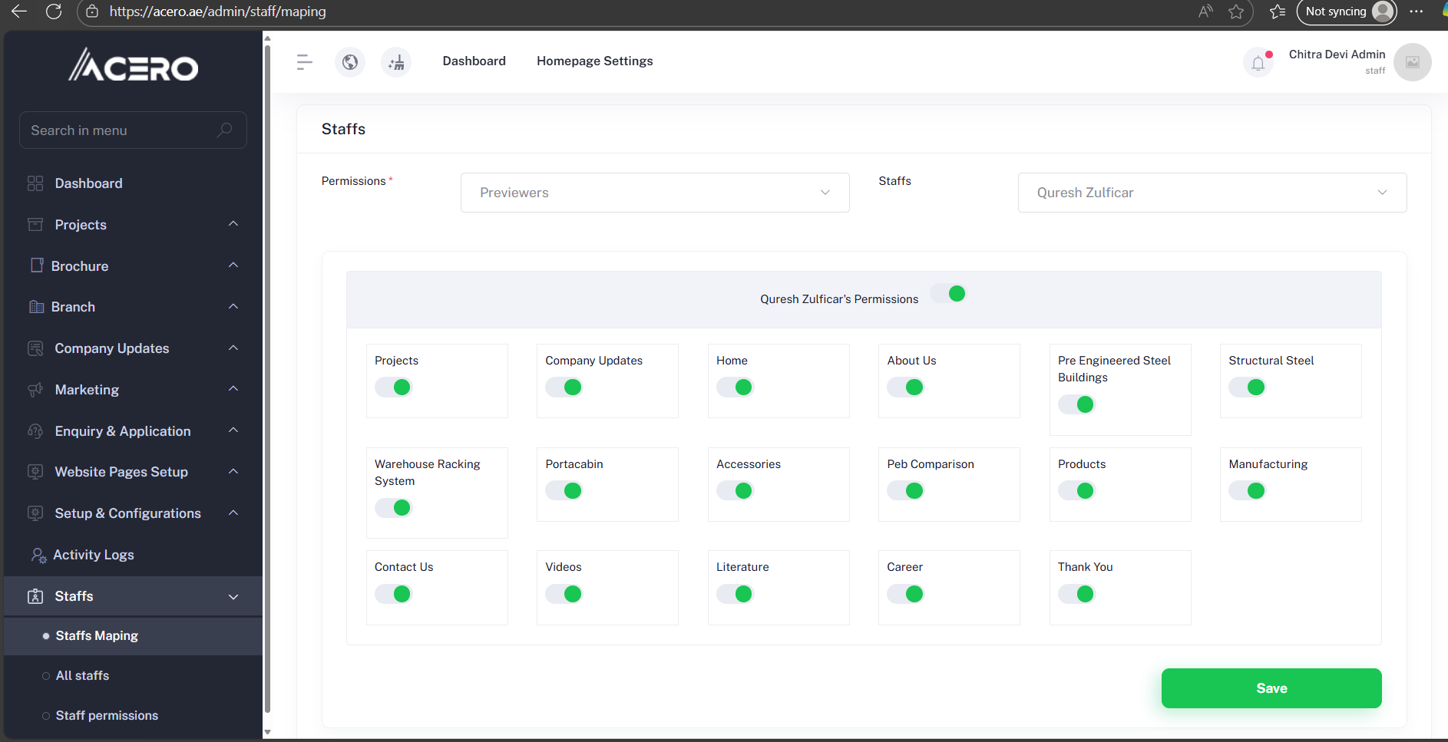

1. Below the staff list, a table of all modules and pages is displayed with toggle buttons.
2. Enable or disable toggles to grant or restrict access per module(Refer below img)
   * Projects
   * Company Updates
   * Brochures
   * Branches
   * Website Pages Setup
   * Marketing
   * Enquiry & Applications
   * Setup & Configurations
   * Activity Logs
   * Staffs

1. Click Update to apply permission changes.

Staff Permissions: Staffs -> Staff Permissions

**All Staffs:**

Clicking on options will allow to edit the listed staff info(Admin only)

